Three Week Planting Design Course Equipment List

- Access to the internet and a printer. – if it can copy or scan this is great. If not, you can use your phone to photograph and print out images by emailing them to yourself.
- You can choose to work digitally on this course – but we will not be teaching desk top publishing skills – rather focusing on planning design itself. However, if you prefer to present your work digitally that is fine. Caroline will be demonstrating with images printed out and stuck down. This is how we start on our professional courses and even if you are a seasoned digital worker – the interaction of handling images is a good learning experience.
- A source of images of plants and gardens that you love. This could be gardening magazines, your own photographs or printed off from the internet.
- Scissors and glue.
- Sketchbook or separate sheets of plain paper to work on for mood boards. Any size will do – Caroline prefers A3 portrait which is quite large – but is a good size for mood boards. Smaller sizes are fine.
- A4 tracing or layout paper. Having both is great. Caroline uses layout for rough work and tracing paper for the final design. But you can work with just one or the other to save on equipment costs. Layout paper is cheaper but less transparent and is best used with pencil. Tracing paper is more expensive and is best used with ink pen because pencil will smudge on tracing paper. Ink on tracing paper gives the most professional results – but pencil on layout is fine to complete the course. Pencil drawings can be inked up later, even after the course.
- Pen and/or pencil. Disposable ink pens such as Tikky are fine for this course. You can go all out and get a Rotring ink pen which will give the best results, but these are expensive. If you decide to go for a professional Rotring ink pen choose a 0;35 nib – this is a good all-rounder. You might need to buy cartridges and ink also – check the details when buying. My favorite pencils are Pental Twist Erase with 0.5 lead, these come with a nice big eraser!
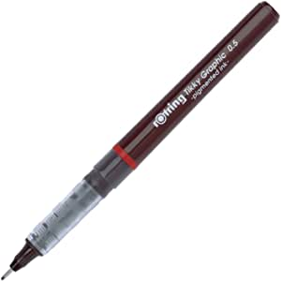
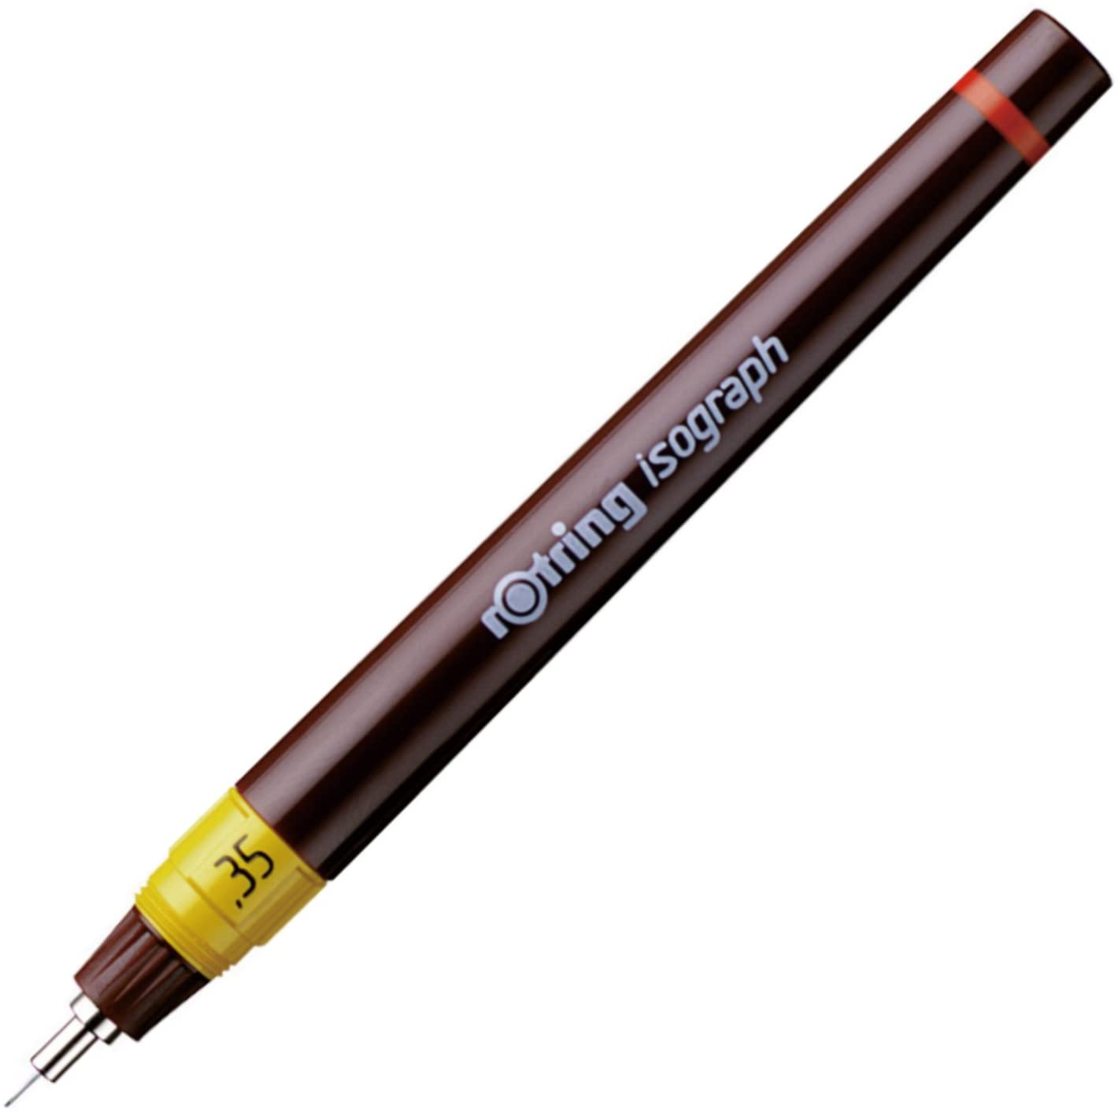
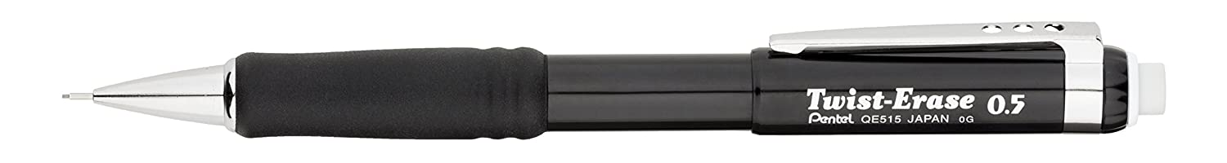
- One sheet of A4 graph paper.
- If using ink pens you will need and ink eraser and
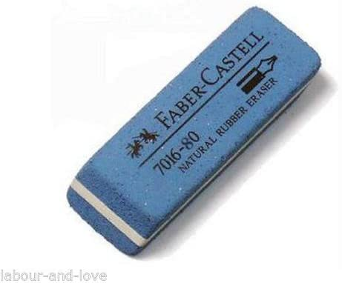
- eraser guard
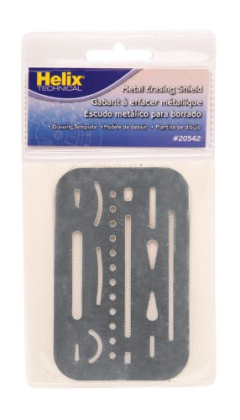
- Circle template
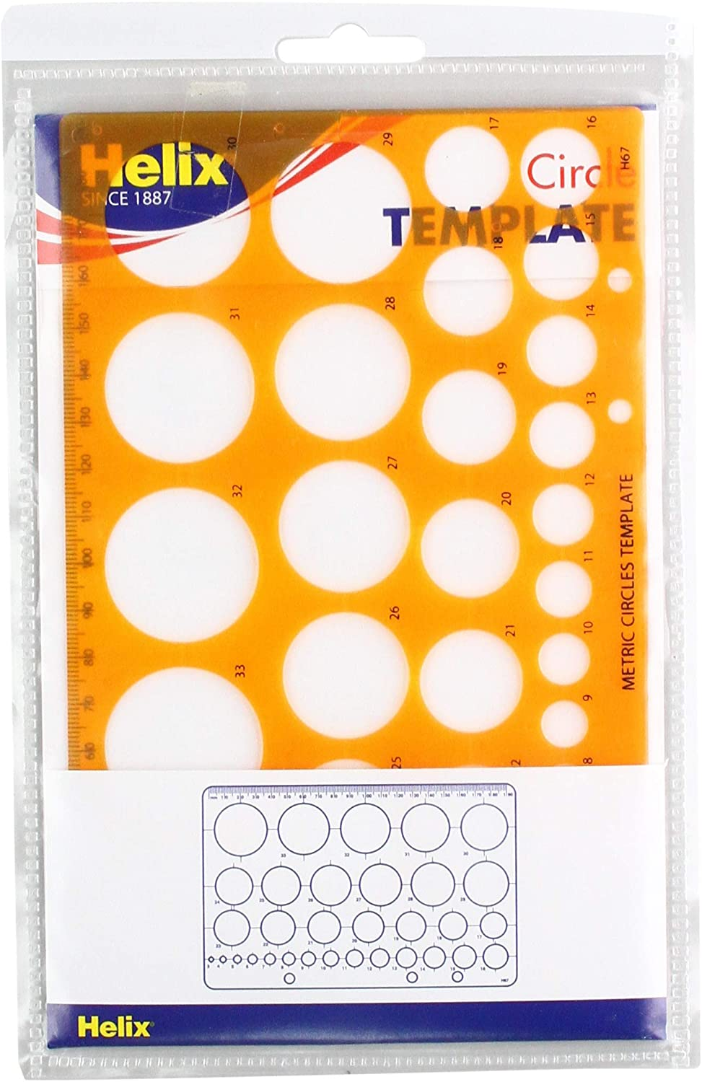
- Plant reference books if you have them - RHS website is a good alternative.

